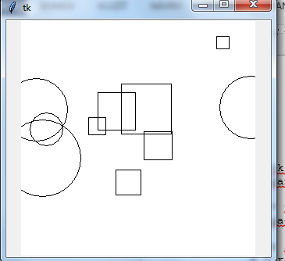Podmienený príkaz

import tkinter

import random

canvas = tkinter.Canvas(bg='white', width=300, height=300)

canvas.pack()

for i in range(10):

x = random.randrange(300)

y = random.randrange(300)

a = random.randrange(5, 50)

if random.randrange(2): # t.j. random.randrange(2) != 0

canvas.create_oval(x-a, y-a, x+a, y+a)

else:

canvas.create_rectangle(x-a, y-a, x+a, y+a)

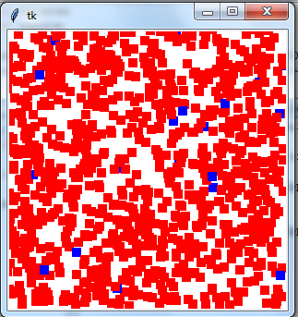

import tkinter

import random

canvas = tkinter.Canvas(bg='white', width=300, height=300)

canvas.pack()

for i in range(1000):

x = random.randrange(300)

y = random.randrange(300)

if random.randrange(50): # t.j. random.randrange(50) != 0

farba = 'red'

else:

farba = 'blue'

canvas.create_rectangle(x-5, y-5, x+5, y+5, fill=farba, outline='')

ZDROJE NA ŠTÚDIUM A CVIČENIE

<https://input.sk/python2017/10.html>